XYLEM
- Tell me about yourself
- Project structure
- Roles and responsibilities
- Have you used redux in your project?
- How you applied redux in your project?
- Redux flow
- What tools you used to debug the code?
- Synthetic events
- Explain box model
- Complete this task using class component with add and search functionality
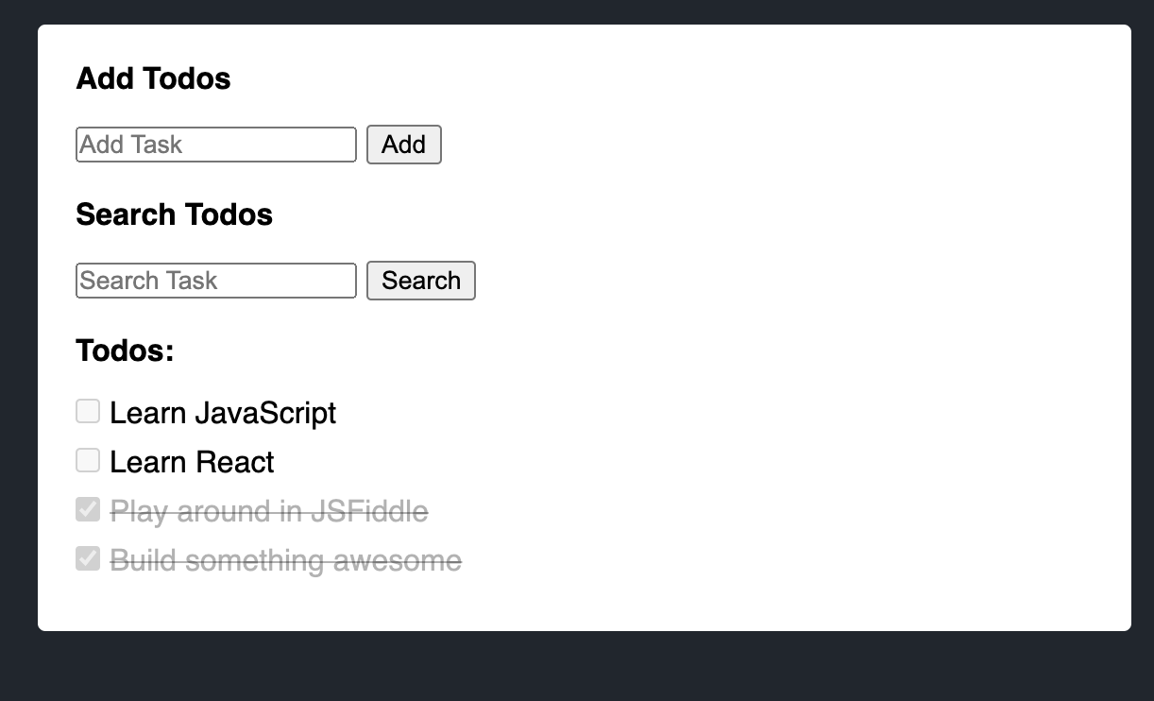

Xylem:
Var let const
Callback with example
Cookies
Redux flow
Es6 features
Box model in CSS
Project explanation
Authentication
Debugging
Performance optimization
Async await
Promises
Polyfills
Redux middleware
Redux thunk
Hooks
Usereducer
Usecallback
Usememo
Use effect
Props and state
Closure
Todo practical
Panel - MO MO SAM
1. Introduction
2. About Project
3. What is callback? Explain one scenario where you have used callback in your project
4. What is redux? Explain how you used redux in your project
5. Explain box model?
6. Do you know chart library
7. List ES6 features and explain them
8. WAP Todo Add and Search

